**Notification test simulator walk through sample:**

Pre setup parameters: Awake: 8:00AM Sleep: 10:00PM, pingNum per day: 2

Step 1) The respondent finishes survey A+B at 9:17AM on June 1 2020, the notification schedules will be calculated and setup:

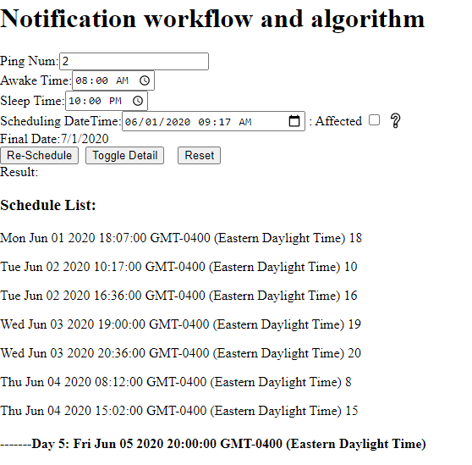

Step 2) The respondent did a survey B at 9:17 PM on June 1,2020,

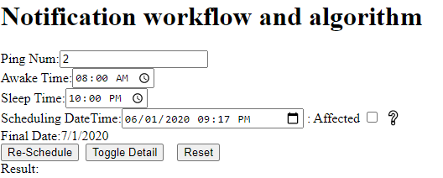



Because the current day is still in the previous scheduled list and you choose not to affect current day. So you get an empty schedule list

Step 3) On June 3,2020 at 7:17PM the respondent did another survey B, the simulator just calculated and appended 2 more days of schedules to the list

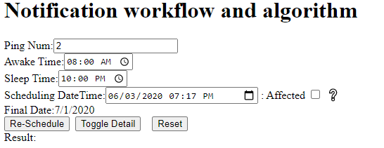

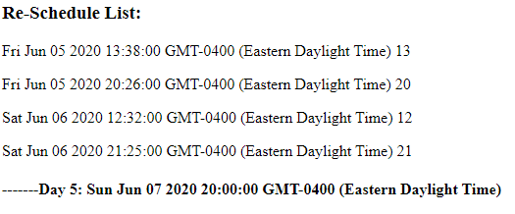

Step 4)On the same day later time the respondent changed his setting to 5 times ping mum per day:

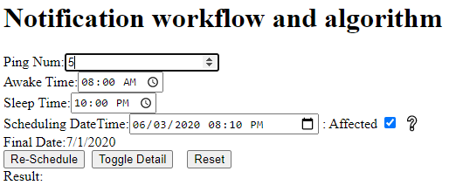

Please be aware of the situation of that On June 3,2020 at 19:00 a notification had already been sent out. The next notification would be sent out at 20:36(from first picture above). Suppose to send 5-1=4 more notification for June 3, but right now it’s 8:10PM already and sleep time is 10:00PM, only 1 notification is available being sent out for this time frame. So you get the following schedule list:

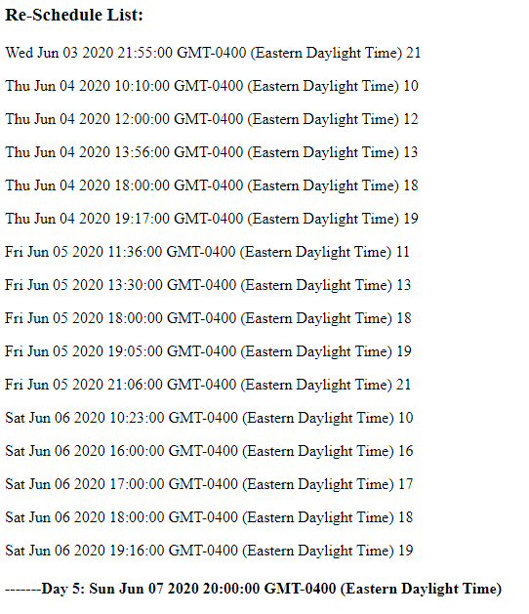

Step 5) For some reason, the respondent was unable to do the survey until day 5 morning (I should do the test after getting remind notification. but I forget to change time, anyway it is almost same, I am lazy to re do-it from beginning, sorry--Jiandong).

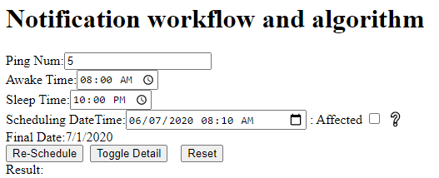

### Re-Schedule List:

Sun Jun 07 2020 15:15:00 GMT-0400 (Eastern Daylight Time) 15

Sun Jun 07 2020 17:30:00 GMT-0400 (Eastern Daylight Time) 17

Sun Jun 07 2020 19:00:00 GMT-0400 (Eastern Daylight Time) 19

Sun Jun 07 2020 20:00:00 GMT-0400 (Eastern Daylight Time) 20

Sun Jun 07 2020 21:40:00 GMT-0400 (Eastern Daylight Time) 21

Mon Jun 08 2020 14:15:00 GMT-0400 (Eastern Daylight Time) 14

Mon Jun 08 2020 16:58:00 GMT-0400 (Eastern Daylight Time) 16

Mon Jun 08 2020 18:53:00 GMT-0400 (Eastern Daylight Time) 18

Mon Jun 08 2020 20:00:00 GMT-0400 (Eastern Daylight Time) 20

Mon Jun 08 2020 21:19:00 GMT-0400 (Eastern Daylight Time) 21

Tue Jun 09 2020 13:33:00 GMT-0400 (Eastern Daylight Time) 13

Tue Jun 09 2020 18:00:00 GMT-0400 (Eastern Daylight Time) 18

Tue Jun 09 2020 19:00:00 GMT-0400 (Eastern Daylight Time) 19

Tue Jun 09 2020 20:00:00 GMT-0400 (Eastern Daylight Time) 20

Tue Jun 09 2020 21:26:00 GMT-0400 (Eastern Daylight Time) 21

Wed Jun 10 2020 15:07:00 GMT-0400 (Eastern Daylight Time) 15

Wed Jun 10 2020 17:00:00 GMT-0400 (Eastern Daylight Time) 17

Wed Jun 10 2020 18:00:00 GMT-0400 (Eastern Daylight Time) 18

Wed Jun 10 2020 19:00:00 GMT-0400 (Eastern Daylight Time) 19

Wed Jun 10 2020 20:50:00 GMT-0400 (Eastern Daylight Time) 20

#### -------Day 5: Thu Jun 11 2020 20:00:00 GMT-0400 (Eastern Daylight Time)

Step 6) On June 9,2020 at 12:10PM, the respondent change setting from ping 5 times per day to 2 times per day:

Since no any notification was sent out yet, so the simulator gives 2 notifications for the day June 9,2020:

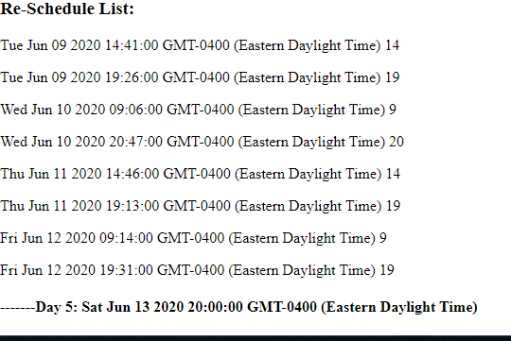

That is all for the this walk through, please play with it and let me know any problem.

Thanks,

Also the following are some individual samples come from Ali’s testing list. Just as a reference.

Ali’s list

1-     Example with default parameters –After survey A done.  
a.      Parameters (8am-10pm)  
b.     Output (times) 2 notifications

Test 1A: current time is before awake time

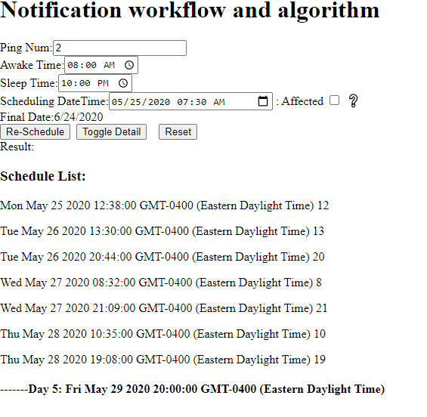

Test 1B: current time is after awake time and before bed time

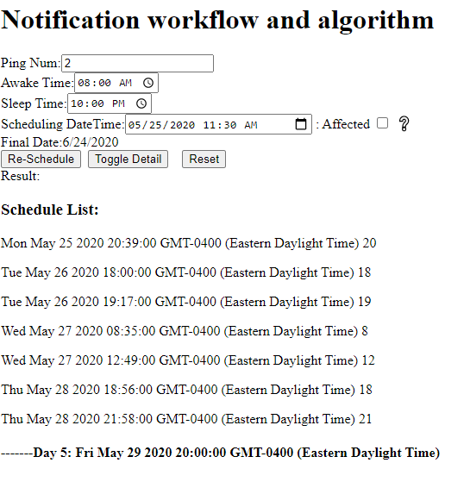

Test 1C: current time is after bed time

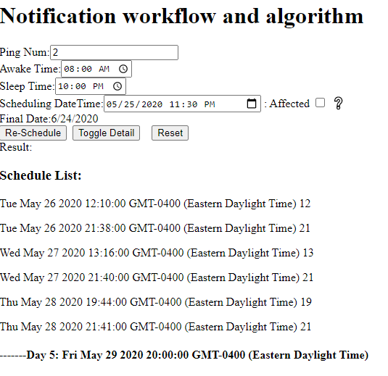

2-     Example with changing settings from 2- 5 on the beginning of the day

2A: PingNum=2:

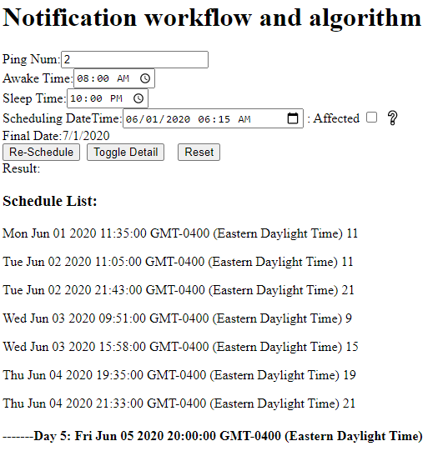

2B: change PingNum to 5:

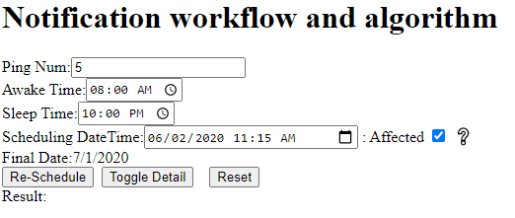

**Re-Schedule List:**

Tue Jun 02 2020 14:06:00 GMT-0400 (Eastern Daylight Time) 14

Tue Jun 02 2020 19:00:00 GMT-0400 (Eastern Daylight Time) 19

Tue Jun 02 2020 20:00:00 GMT-0400 (Eastern Daylight Time) 20

Tue Jun 02 2020 21:06:00 GMT-0400 (Eastern Daylight Time) 21

Wed Jun 03 2020 08:40:00 GMT-0400 (Eastern Daylight Time) 8

Wed Jun 03 2020 13:52:00 GMT-0400 (Eastern Daylight Time) 13

Wed Jun 03 2020 18:00:00 GMT-0400 (Eastern Daylight Time) 18

Wed Jun 03 2020 19:58:00 GMT-0400 (Eastern Daylight Time) 19

Wed Jun 03 2020 21:16:00 GMT-0400 (Eastern Daylight Time) 21

Thu Jun 04 2020 12:44:00 GMT-0400 (Eastern Daylight Time) 12

Thu Jun 04 2020 18:00:00 GMT-0400 (Eastern Daylight Time) 18

Thu Jun 04 2020 19:00:00 GMT-0400 (Eastern Daylight Time) 19

Thu Jun 04 2020 20:00:00 GMT-0400 (Eastern Daylight Time) 20

Thu Jun 04 2020 21:40:00 GMT-0400 (Eastern Daylight Time) 21

Fri Jun 05 2020 11:49:00 GMT-0400 (Eastern Daylight Time) 11

Fri Jun 05 2020 14:29:00 GMT-0400 (Eastern Daylight Time) 14

Fri Jun 05 2020 17:52:00 GMT-0400 (Eastern Daylight Time) 17

Fri Jun 05 2020 19:00:00 GMT-0400 (Eastern Daylight Time) 19

Fri Jun 05 2020 20:25:00 GMT-0400 (Eastern Daylight Time) 20

**-------Day 5: Sat Jun 06 2020 20:00:00 GMT-0400 (Eastern Daylight Time)**

3-     Example with changing settings from 2- 5 on the middle of the day

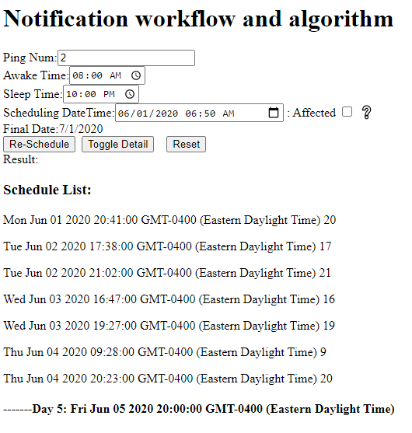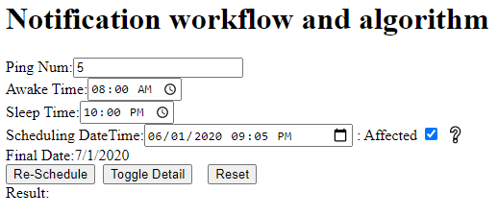

### Re-Schedule List: (here no more available interval for arrange notification now, too late 9:05PM)

Tue Jun 02 2020 17:00:00 GMT-0400 (Eastern Daylight Time) 17

Tue Jun 02 2020 18:00:00 GMT-0400 (Eastern Daylight Time) 18

Tue Jun 02 2020 19:00:00 GMT-0400 (Eastern Daylight Time) 19

Tue Jun 02 2020 20:00:00 GMT-0400 (Eastern Daylight Time) 20

Tue Jun 02 2020 21:38:00 GMT-0400 (Eastern Daylight Time) 21

Wed Jun 03 2020 13:37:00 GMT-0400 (Eastern Daylight Time) 13

Wed Jun 03 2020 18:00:00 GMT-0400 (Eastern Daylight Time) 18

Wed Jun 03 2020 19:00:00 GMT-0400 (Eastern Daylight Time) 19

Wed Jun 03 2020 20:00:00 GMT-0400 (Eastern Daylight Time) 20

Wed Jun 03 2020 21:49:00 GMT-0400 (Eastern Daylight Time) 21

Thu Jun 04 2020 09:38:00 GMT-0400 (Eastern Daylight Time) 9

Thu Jun 04 2020 15:09:00 GMT-0400 (Eastern Daylight Time) 15

Thu Jun 04 2020 17:49:00 GMT-0400 (Eastern Daylight Time) 17

Thu Jun 04 2020 19:00:00 GMT-0400 (Eastern Daylight Time) 19

Thu Jun 04 2020 21:44:00 GMT-0400 (Eastern Daylight Time) 21

#### -------Day 5: Fri Jun 05 2020 20:00:00 GMT-0400 (Eastern Daylight Time)

4-     Example with changing settings from 2- 5 on the at the end of the day  
5-     Example with changing settings from 2- 5 on outside the hours  
6-     Example with changing settings from 5-3 on the beginning of the day

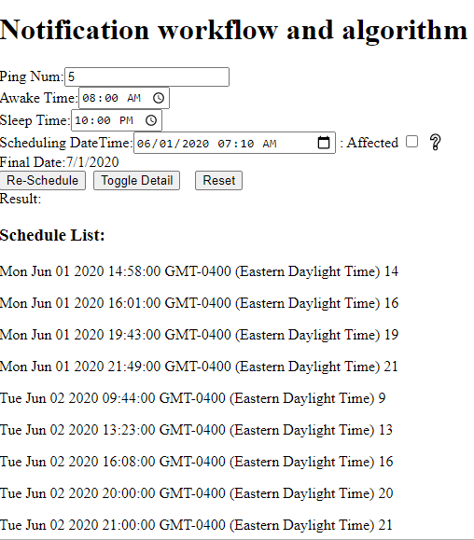

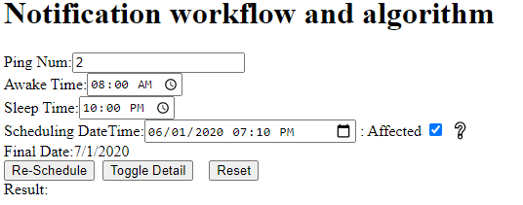

### Re-Schedule List: (up to 7:10PM, 1+2 notification have been sent out, so no schedules for June 1)

Tue Jun 02 2020 10:41:00 GMT-0400 (Eastern Daylight Time) 10

Tue Jun 02 2020 17:57:00 GMT-0400 (Eastern Daylight Time) 17

Wed Jun 03 2020 14:32:00 GMT-0400 (Eastern Daylight Time) 14

Wed Jun 03 2020 16:23:00 GMT-0400 (Eastern Daylight Time) 16

Thu Jun 04 2020 20:00:00 GMT-0400 (Eastern Daylight Time) 20

Thu Jun 04 2020 21:20:00 GMT-0400 (Eastern Daylight Time) 21

#### -------Day 5: Fri Jun 05 2020 20:00:00 GMT-0400 (Eastern Daylight Time)

7-     Example with changing settings from 5-3 on the middle of the day  
8-     Example with changing settings from 5-3 on the end of the day  
9-     Example with changing settings from 5-3 on outside the hours10-  Example with different parameters –After survey A done.  
a.      Parameters (8am-11am)  
b.     Output (times) 2 notifications11-   Example with different parameters –After survey A done.  
a.      Parameters (8am-11am)  
b.     Output (times) 5 notifications12-  Example with different parameters –After survey A done.  
a.      Parameters (8am-11am)  
b.     Output (times) 2 notifications13-   Example with different parameters –After survey A done.  
a.      Parameters (10pm-4am)  
b.     Output (times) 5 notifications14-  Example with different parameters –After survey A done.  
a.      Parameters (10pm-4am)  
b.     Output (times) 5 notifications